**Project Report**

**Project Title : Digital Hospital Management System**

**Organization: Lovely Professional University**

**Prepared For: Dr. Siddardha Dasari**

**Prepared By:**

|  |  |  |
| --- | --- | --- |
| **S no.** | **Name** | **Registration No.** |
| **1** | **Amanjot Singh** | **12309766** |
| **2** | **Roshan Pal** | **12325961** |
| **3** | **Palika Ghai** | **12310349** |

**Date: 20-Feb-2026**

**1. Executive Summary**

**The Hospital Management System (HMS) is a comprehensive web-based healthcare management platform developed to modernize and digitize hospital operations. The system is designed to replace traditional paper-based processes with a centralized, automated, and efficient digital solution that improves workflow coordination between patients, pharmacists, and hospital staff.**

**In conventional hospital environments, manual record-keeping and fragmented systems often lead to data inconsistencies, prescription errors, delayed billing, and inefficient communication between departments. These challenges reduce operational efficiency and negatively impact patient satisfaction. The proposed Hospital Management System addresses these issues by integrating patient management, prescription handling, pharmacy operations, inventory management, and billing processes into a unified platform.**

**The primary objective of this project is to develop a secure and scalable web application that simplifies hospital operations while enhancing data accuracy and service delivery speed. By utilizing modern web technologies such as Python and Django for backend development and HTML/CSS for frontend design, the system ensures structured workflow management, secure authentication, and reliable database handling.**

**The system provides the following core functionalities:**

* **Secure patient registration and login system**
* **Digital prescription viewing and uploading**
* **Online medicine ordering with prescription verification**
* **Pharmacy dashboard for order management and inventory control**
* **Automated shopping cart and bill generation system**
* **Role-based access control for different hospital departments**

**The application follows a modular architecture, enabling easy scalability and future enhancements such as payment gateway integration, real-time notifications, analytics dashboards, and cloud deployment.**

**The expected outcome of this project is a user-friendly, secure, and efficient hospital management solution that reduces administrative workload, minimizes errors, improves inventory tracking, and enhances overall patient experience. The system demonstrates how digital transformation can significantly improve healthcare service delivery and operational transparency.**

**2. Project Overview**

**Business Problem Statement**

**Traditional hospital management systems often rely on fragmented software solutions and manual record-keeping processes, which result in operational inefficiencies, data redundancy, billing inaccuracies, delayed prescription processing, and poor coordination between departments such as pharmacy, reception, and patient services. These legacy workflows reduce service speed and compromise data integrity, especially when handling prescription uploads, medicine inventory management, and billing automation.**

**The technical challenge was to design and implement a secure, database-driven hospital management platform capable of handling patient authentication, prescription uploads, pharmacy inventory control, shopping cart billing workflows, and order fulfillment processes within a centralized, scalable, and modular architecture. The system needed to ensure secure session-based authentication, structured database relationships, controlled access to sensitive modules, and seamless workflow transitions between patient and pharmacy interfaces.**

|  |
| --- |
| **Project Objectives** |
| |  |  |  | | --- | --- | --- | | **Objective ID** | **Description** | **Key Deliverable** | | **O-01** | **Secure Role-Based Authentication** | **Implement a session-based authentication system using Django’s framework, ensuring user credentials are securely managed with form validation, CSRF protection, and controlled dashboard access for Patients, Pharmacists, and Receptionists.** | | **O-02** | **Prescription & File Management** | **Develop a secure file upload system using Django’s MEDIA handling to allow patients to upload prescriptions while ensuring structured storage and retrieval by the pharmacy module.** | | **O-03** | **Pharmacy Inventory & Order Workflow** | **Design a relational database schema (models.py) to manage medicines, shopping cart items, and billing workflows while maintaining real-time stock updates and accurate order tracking.** | |

|  |
| --- |
| **Scope:** |
|  |
| |  |  |  | | --- | --- | --- | | **Category** | **Description** | **Status** | | **Authentication** | **User registration, login, session management, and role-based access control.** | **In Scope** | | **Prescription System** | **Secure prescription upload, viewing, and pharmacy access.** | **In Scope** | | **Pharmacy Dashboard** | **Medicine CRUD operations, inventory management, cart handling, and bill generation.** | **In Scope** | | **Billing & Cart Module** | **Dynamic cart calculation, order fulfillment, and bill completion workflow.** | **In Scope** | | **Online Payment Gateway** | **Integration with external payment systems (Razorpay/Stripe).** | **Out-of-Scope (Phase 1)** | | **AI-driven Analytics** | **Predictive analytics, automated stock forecasting, or ML-based recommendation systems.** | **Out-of-Scope (Future Enhancement)** | |

**Key Deliverables & Success Criteria**

**The project success was measured across three primary dimensions:**

**● Functional Codebase:  
A fully operational Django-based Hospital Management System implementing secure authentication, prescription upload handling, pharmacy inventory management, and automated billing workflow.**

**● Technical Documentation:  
Comprehensive documentation including architecture design, database schema explanation, system workflow, and security posture analysis.**

**● System Performance & Reliability:  
Efficient database queries using Django ORM, elimination of redundant queries, structured model relationships, and stable session-based authentication without unauthorized access to restricted modules.**

**3. Solution Architecture & Design**

**3.1 System Overview**

**The foundational architecture of the Hospital Management System (HMS) adheres to a Modular Multi-Tier Architecture Pattern, built upon Django’s Model-View-Template (MVT) framework. The system is designed to ensure separation of concerns between presentation logic, application processing, and data persistence layers while maintaining scalability and security.**

**The system operates primarily through a synchronous server process:**

**Synchronous WSGI Layer:  
Handles structured HTTP request-response cycles including user registration, login authentication, prescription uploads, medicine inventory management, cart operations, and billing workflows. This layer processes user requests through Django views and renders dynamic templates based on role-based access permissions.**

**Unlike real-time chat systems, the HMS platform is workflow-driven rather than event-stream driven. Therefore, the architecture focuses on transactional consistency, secure session handling, and structured database interaction instead of persistent WebSocket communication.**

**The application enforces role-based separation across:**

* **Patient Interface**
* **Pharmacy Dashboard**
* **Reception Management Module**

**Each module communicates with the centralized backend while maintaining controlled access through session validation and middleware enforcement.**

**The system follows a three-layer logical separation:**

1. **Presentation Layer (HTML/CSS Dashboards)**
2. **Application Layer (Django Business Logic)**
3. **Data Layer (Relational Database using ORM)**

|  |
| --- |
| **3.2 Technology Stack** |
|  |
|  |
| |  |  |  | | --- | --- | --- | | **Component Category** |  | **Technology** | | **Backend Framework** |  | **Python 3.x, Django** | | **Frontend Interface** |  | **HTML5, CSS3** | | **Primary Database** |  | **SQLite (Development), PostgreSQL-ready** | | **Authentication Module** |  | **Django Session-Based Authentication** | | **File Management** |  | **Django MEDIA Handling** | | **Email Integration** |  | **Django SMTP (send_mail)** | | **Development Environment** |  | **VS Code, Git, Django Admin** | |

**3.3 Integration Points**

**● File Storage (Prescription Upload):  
User-uploaded prescription documents are stored securely using Django’s MEDIA configuration. Files are saved in a dedicated media directory on the server, and only file paths are stored in the relational database. This ensures structured file handling without bloating database storage.**

**● Email Notification System:  
The system integrates Django’s SMTP utilities to send automated email notifications upon user registration and order confirmation. Email dispatch is handled within the application layer to maintain workflow continuity.**

**● Session-Based Access Control:  
All dashboard modules enforce controlled access via session validation. Unauthorized users attempting to access restricted endpoints are redirected to the login interface.**

**3.4 Security**

**The system’s security posture is based on layered protection mechanisms implemented through Django’s framework:**

**● Session-Based Authentication:  
User authentication is managed using Django’s secure session framework. Session identifiers are stored server-side to prevent credential exposure and unauthorized access.**

**● CSRF Protection:  
All form submissions utilize Django’s CSRF middleware, which enforces randomized tokens for state-changing HTTP requests, mitigating Cross-Site Request Forgery attacks.**

**● Input Validation & ORM Protection:  
All database interactions are handled through Django ORM, preventing raw SQL query execution and mitigating SQL injection vulnerabilities.**

**● Controlled File Upload Handling:  
Prescription file uploads are validated through server-side checks to ensure safe file handling and structured storage.**

**● Role-Based Access Enforcement:  
Dashboard routes are protected to ensure that only authorized users (Patients, Pharmacists, Receptionists) can access their respective modules.**

**3.5 Scalability**

**The architecture is designed with forward scalability considerations:**

**● Modular Application Structure:  
The system is divided into separate Django applications (patients, pharmacy, accounts), allowing independent scaling and maintainability.**

**● Database Migration Readiness:  
Although SQLite is used during development, the database schema is fully compatible with PostgreSQL or MySQL for production deployment.**

**● Optimized Database Queries:  
The system utilizes efficient ORM querying strategies to minimize redundant database calls and prevent inefficient data retrieval patterns.**

**● Horizontal Deployment Capability:  
The application can be deployed using WSGI servers such as Gunicorn combined with Nginx, enabling horizontal scaling across multiple instances in a production environment.**

**Architectural Summary**

**The Hospital Management System demonstrates a structured, secure, and modular backend architecture that efficiently handles authentication, prescription uploads, inventory management, and billing workflows. The design prioritizes transactional integrity, secure access control, and scalable deployment readiness, ensuring that the system can evolve into a production-grade .**

**4. Implementation Plan (9-Day Timeline)**

**The Hospital Management System (HMS) was developed within a focused 9-day intensive development cycle. The implementation was divided into four structured phases to ensure systematic progress, risk control, and feature validation.**

|  |
| --- |
| **Phase Breakdown** |
| |  |  |  |  | | --- | --- | --- | --- | | **Phase / Days** | **Focus Area** | **Key Activities** | **Risk Assessment & Mitigation** | | **Phase 1: Days 1–2** | **Requirements Analysis, Architecture Setup & Authentication Module** | **Finalize system architecture (Django MVT structure). Create project structure and apps (patients, pharmacy, accounts). Implement database schema (models.py). Develop secure registration and login functionality with session handling. Configure SQLite and Django Admin panel.** | **Risk: Database migration conflicts — Mitigation: Strict execution of version-controlled migrations (makemigrations / migrate) after every model change.** | | **Phase 2: Days 3–5** | **Core Development: Pharmacy Module & Inventory Management** | **Implement Medicine Model with full CRUD operations. Develop Pharmacy Dashboard UI. Create Shopping Cart and Order Models. Implement cart logic and total price calculation. Integrate role-based dashboard routing.** | **Risk: Incorrect stock calculation or data inconsistency — Mitigation: Implement validation checks before order confirmation and enforce controlled database updates via ORM.** | | **Phase 3: Days 6–7** | **Prescription Upload & Order Workflow Integration** | **Implement Prescription Model and file upload handling using Django MEDIA configuration. Develop patient interface for uploading prescriptions. Link prescription orders to pharmacy dashboard. Integrate billing generation workflow. Add email notification functionality for registration and order confirmation.** | **Risk: File upload vulnerabilities — Mitigation: Enforce file validation, controlled storage paths, and server-side validation checks.** | | **Phase 4: Days 8–9** | **UI Refinement, Testing & Quality Assurance** | **Refine dashboard UI/UX (Landing Page, Login, Pharmacy Dashboard). Conduct unit testing of authentication and cart workflow. Test order-to-bill lifecycle. Validate session-based access control. Finalize project documentation and performance checks.** | **Risk: Unauthorized dashboard access — Mitigation: Implement session validation checks on all protected routes and verify CSRF protection across forms.** | |

**Resource Allocation**

**The 9-day development sprint required efficient utilization of software tools, development frameworks, and infrastructure resources to ensure timely and high-quality project delivery.**

**● Software and Development Tools**

**○ Backend Framework: Python 3.x, Django  
○ Frontend Technologies: HTML5, CSS3  
○ Database: SQLite (Development Environment)  
○ Email Integration: Django SMTP (send_mail)  
○ Source Control: Git & GitHub  
○ Development Environment: Visual Studio Code**

**● Infrastructure**

**○ Development Environment:  
Local development server using Django’s built-in development server for rapid prototyping and testing.**

**○ Testing Environment:  
Local browser-based testing across multiple modules including authentication, cart operations, billing workflow, and file upload functionality.**

**○ Production Readiness (Future Scope):  
The system architecture supports migration to PostgreSQL and deployment using Gunicorn + Nginx on cloud platforms such as AWS or Heroku.**

**5. Development Team Introduction**

**The 9-day project was executed by a specialized team of four, with roles designed for maximum focus and efficiency across the key architectural domains:**

|  |  |  |  |  |  |  |  |  |  |  |  |  |  |  |  |  |
| --- | --- | --- | --- | --- | --- | --- | --- | --- | --- | --- | --- | --- | --- | --- | --- | --- |
| |  |  |  |  | | --- | --- | --- | --- | | **Role** | **Name** | **Experience** | **Responsibilities** | | **Project Lead & Backend Architect** | **Amanjot** | **Student** | **Overall system architecture design, database schema modeling (models.py), authentication system implementation, session management, and core business logic development.** | | **Frontend & UI Developer** | **Palika** | **Student** | **Design and implementation of responsive dashboards (Patient, Pharmacy, Landing Page), HTML/CSS styling, user interface optimization, and form validation integration.** | | **Database & Workflow Integration Developer** | **Roshan** | **Student** | **Implementation of pharmacy inventory module, cart & billing workflow logic, prescription upload handling, testing, and integration between patient and pharmacy modules.** | |

**6.ScreenShots of website**

**1-Home Page**

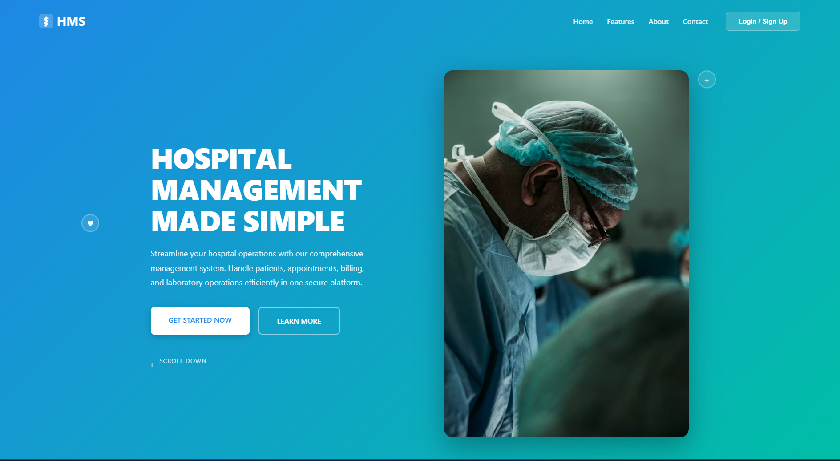

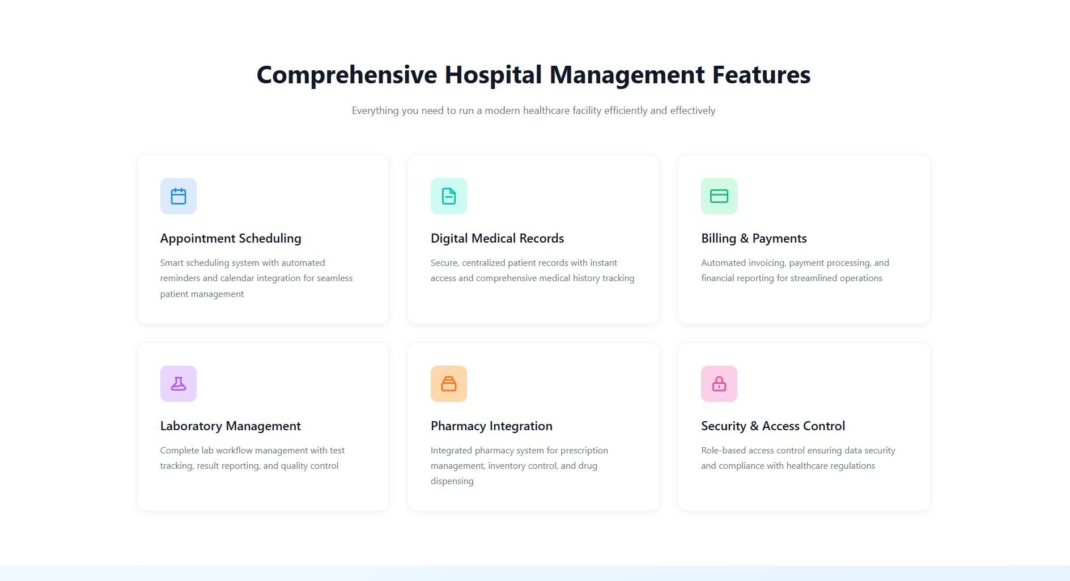

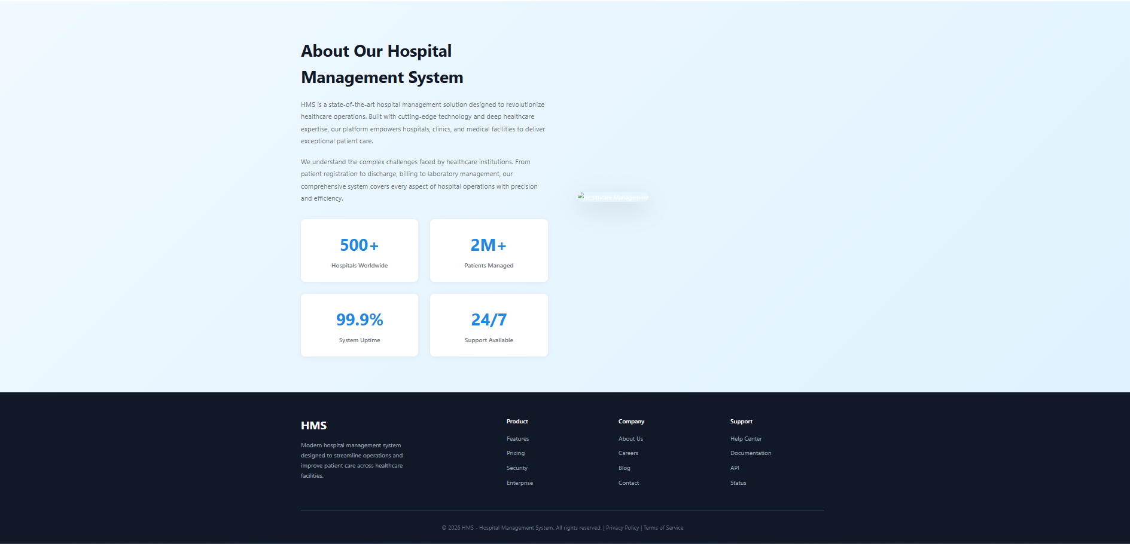

**2-Patient(login page & home page)**

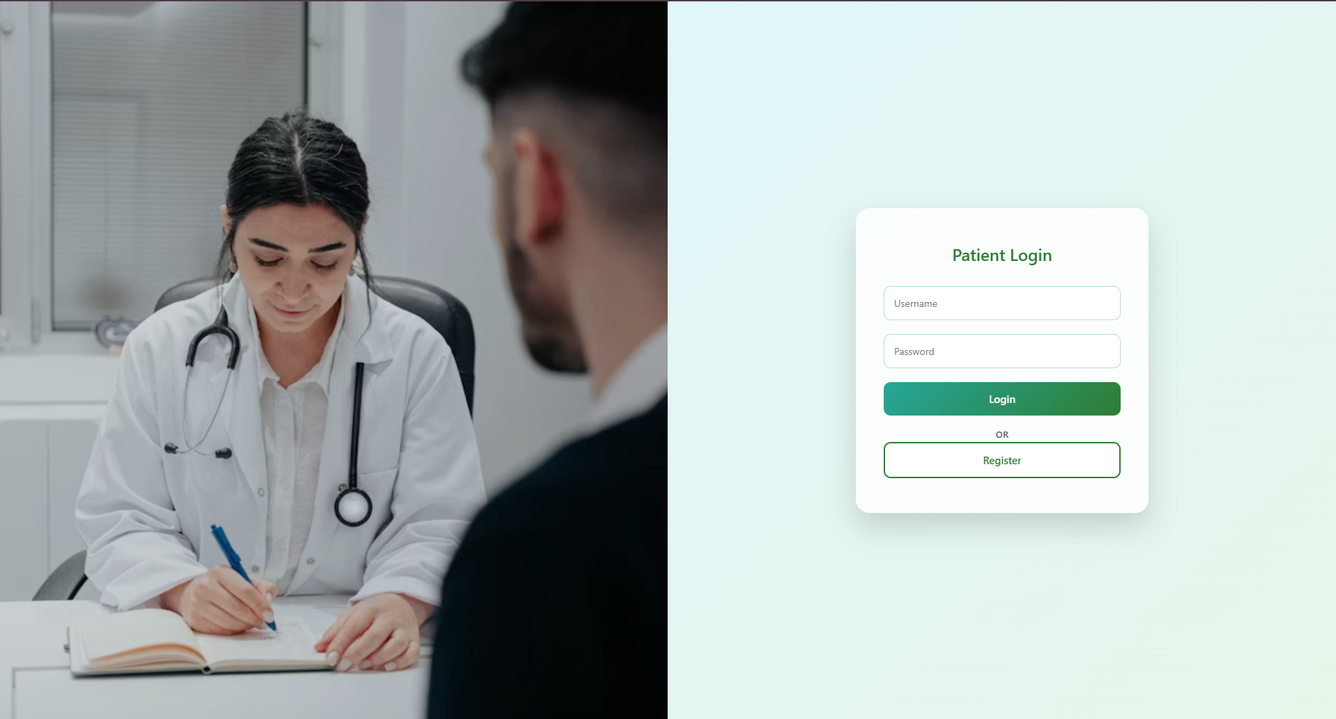

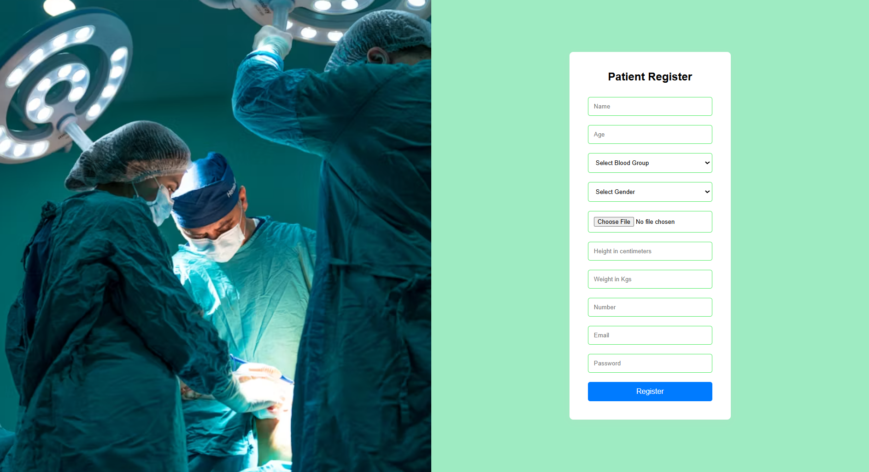

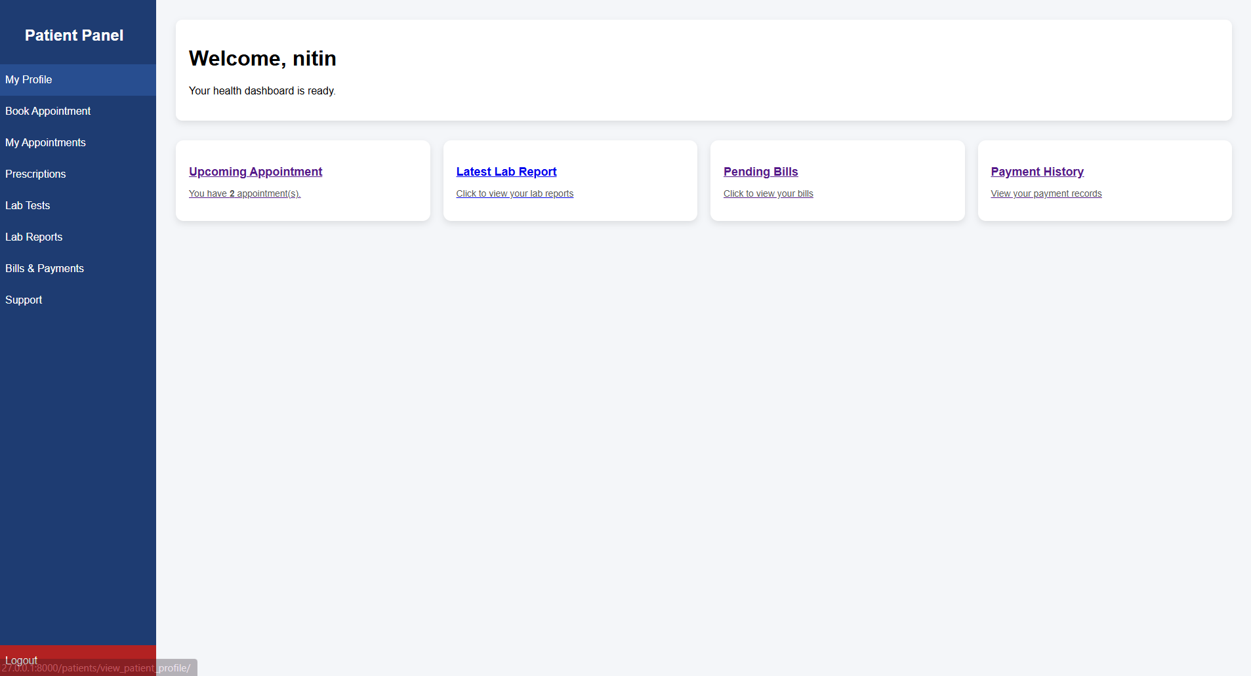

**3-Doctor(login page & home page)**

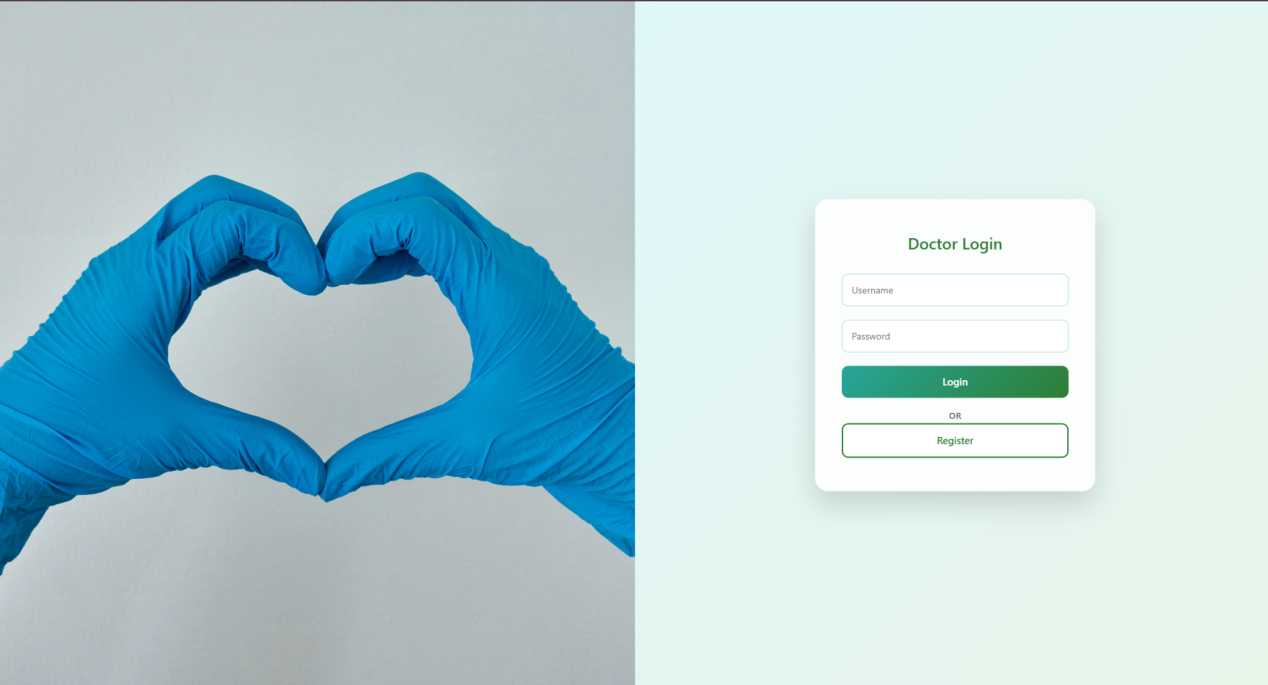

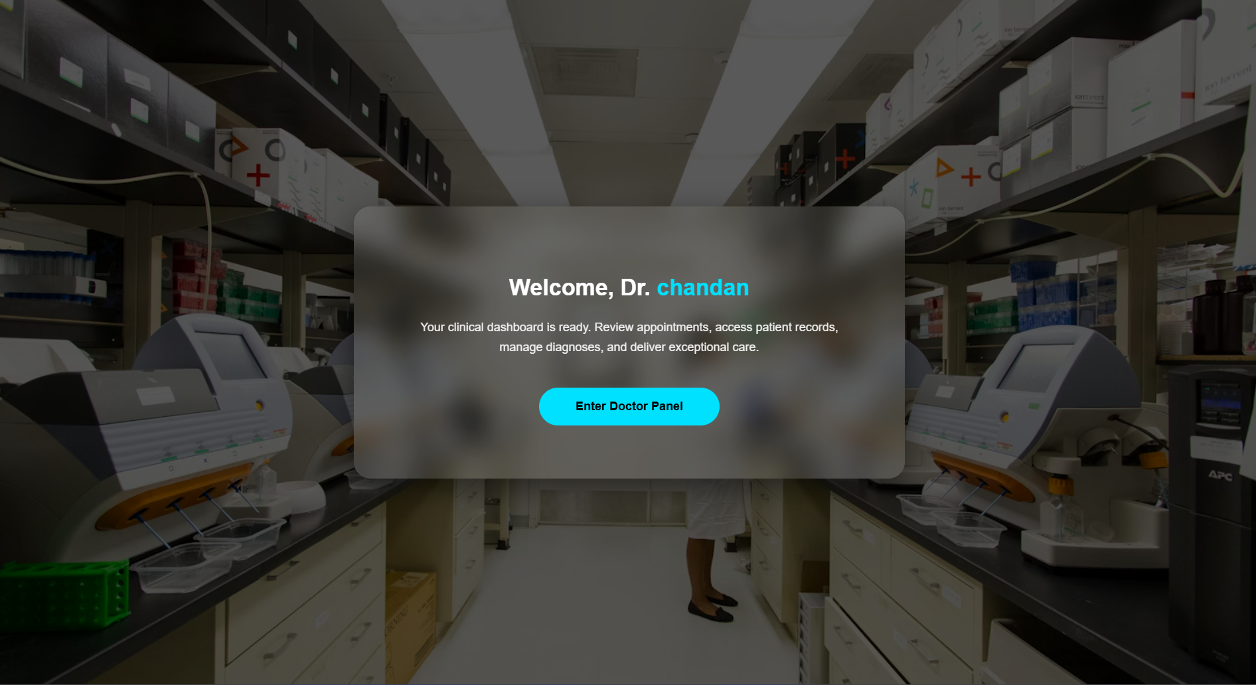 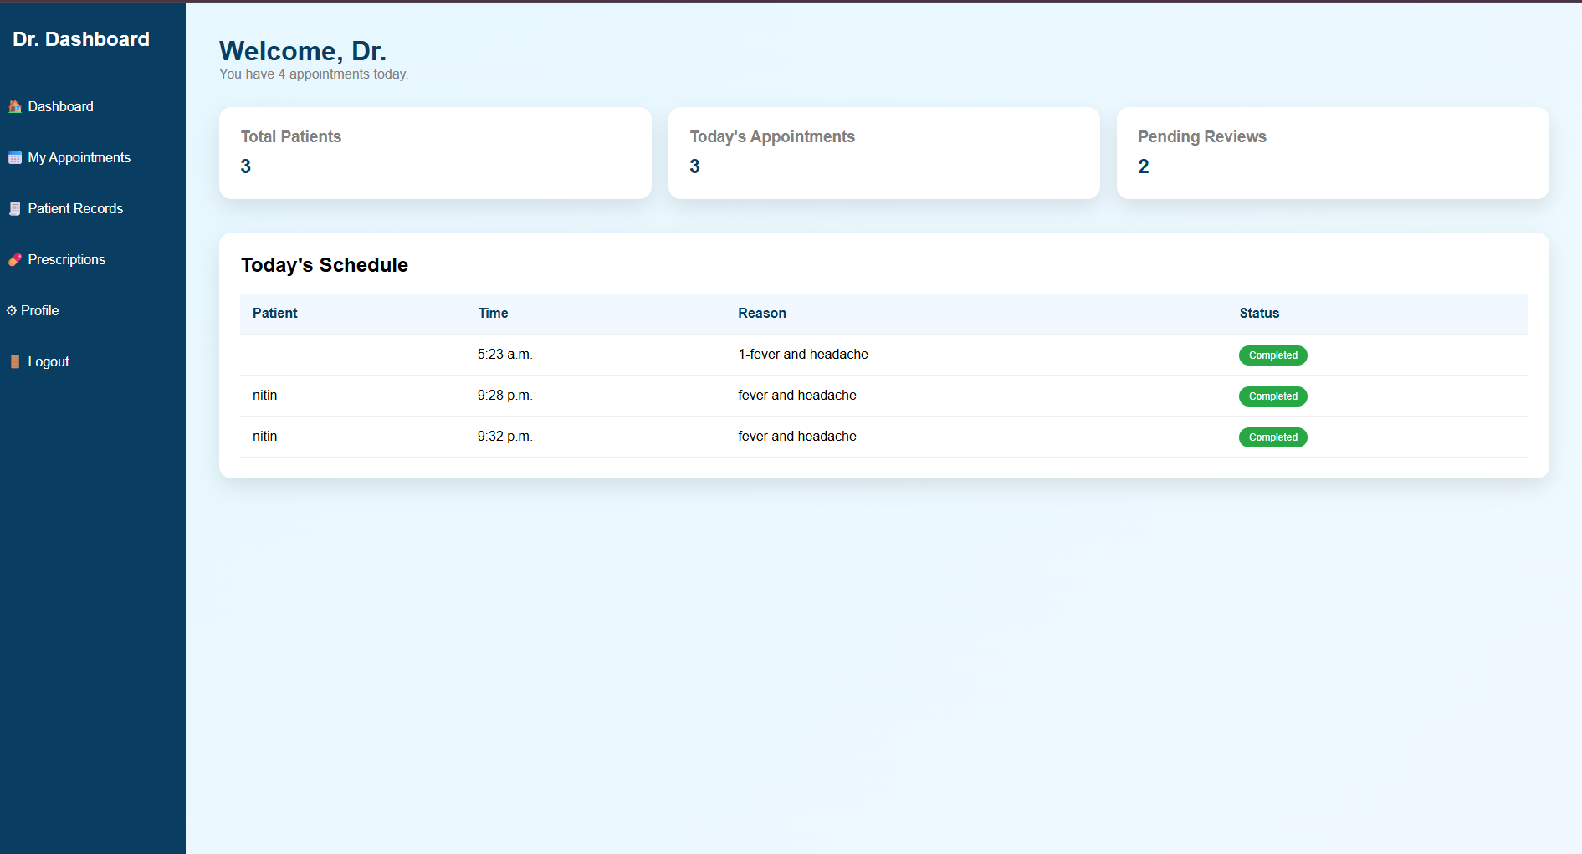

**4-Recptionist(login page & home page)**

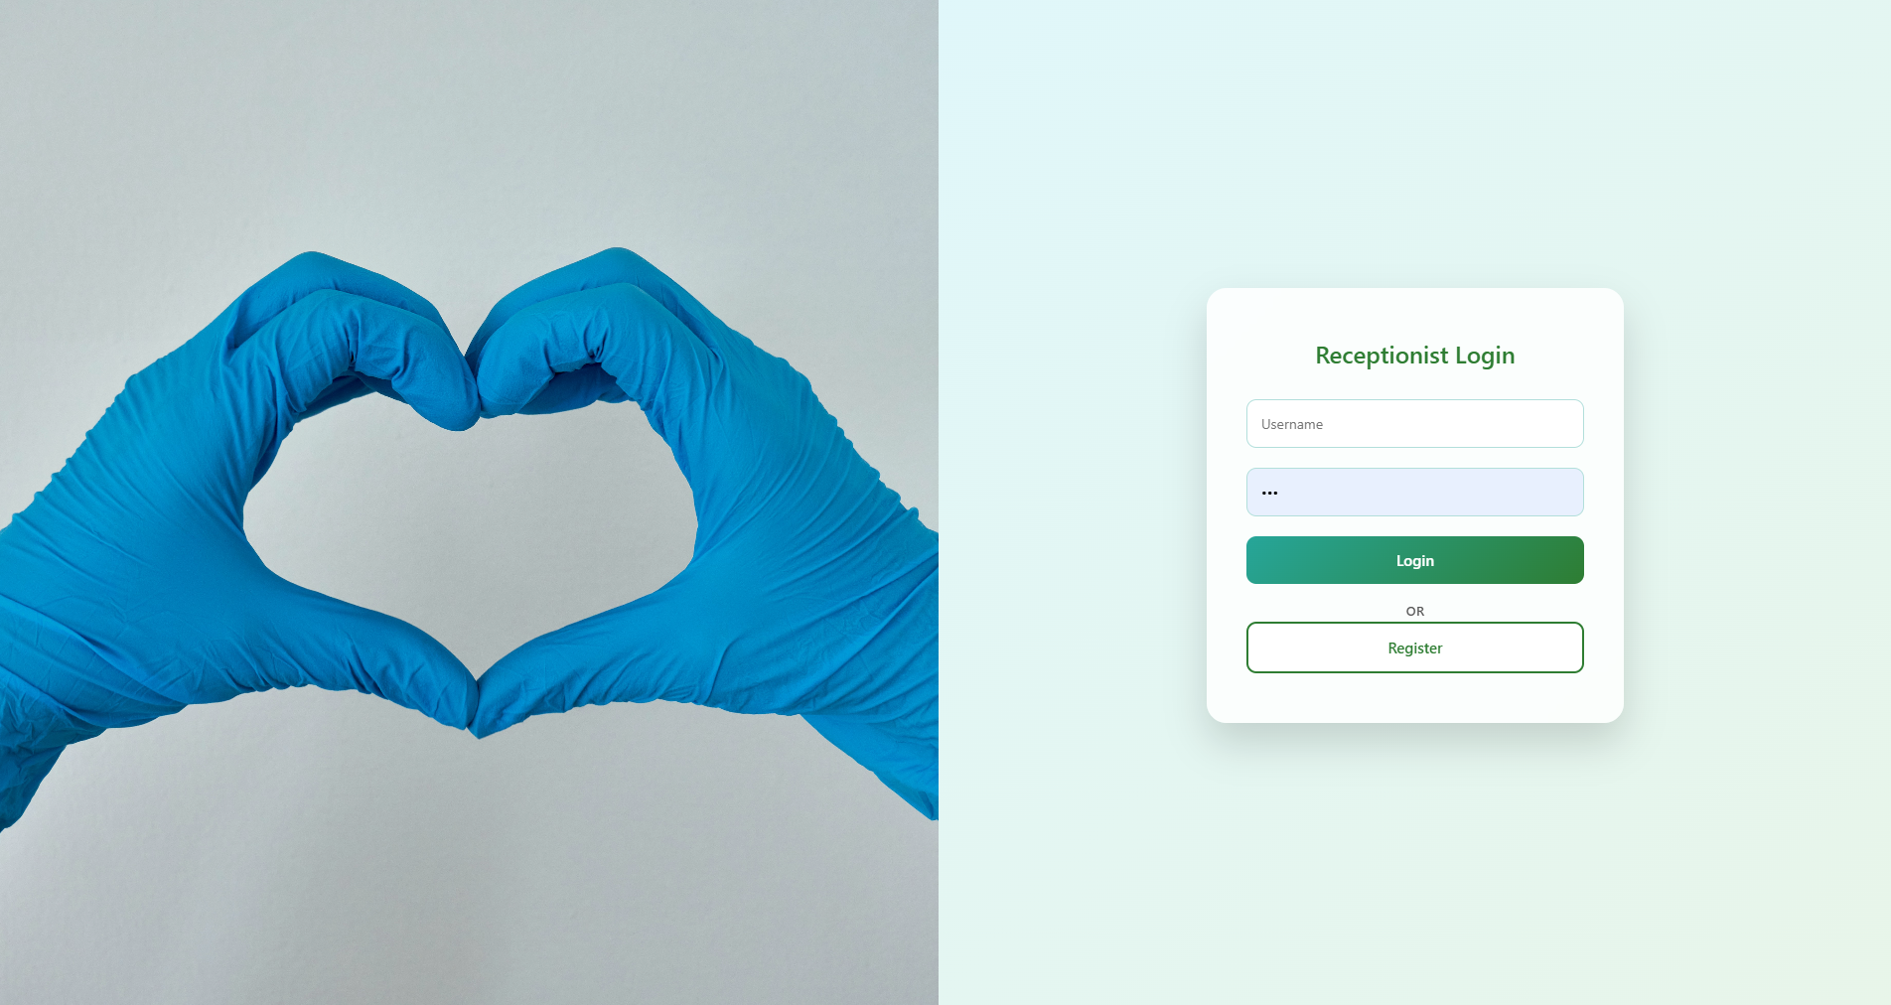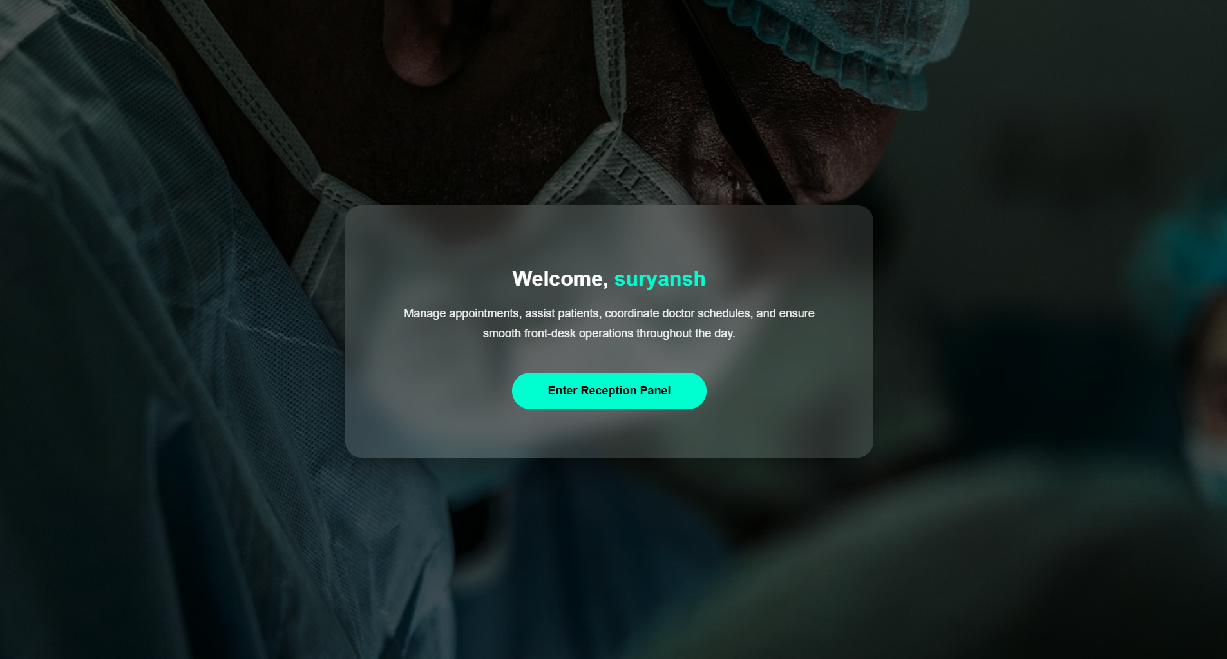

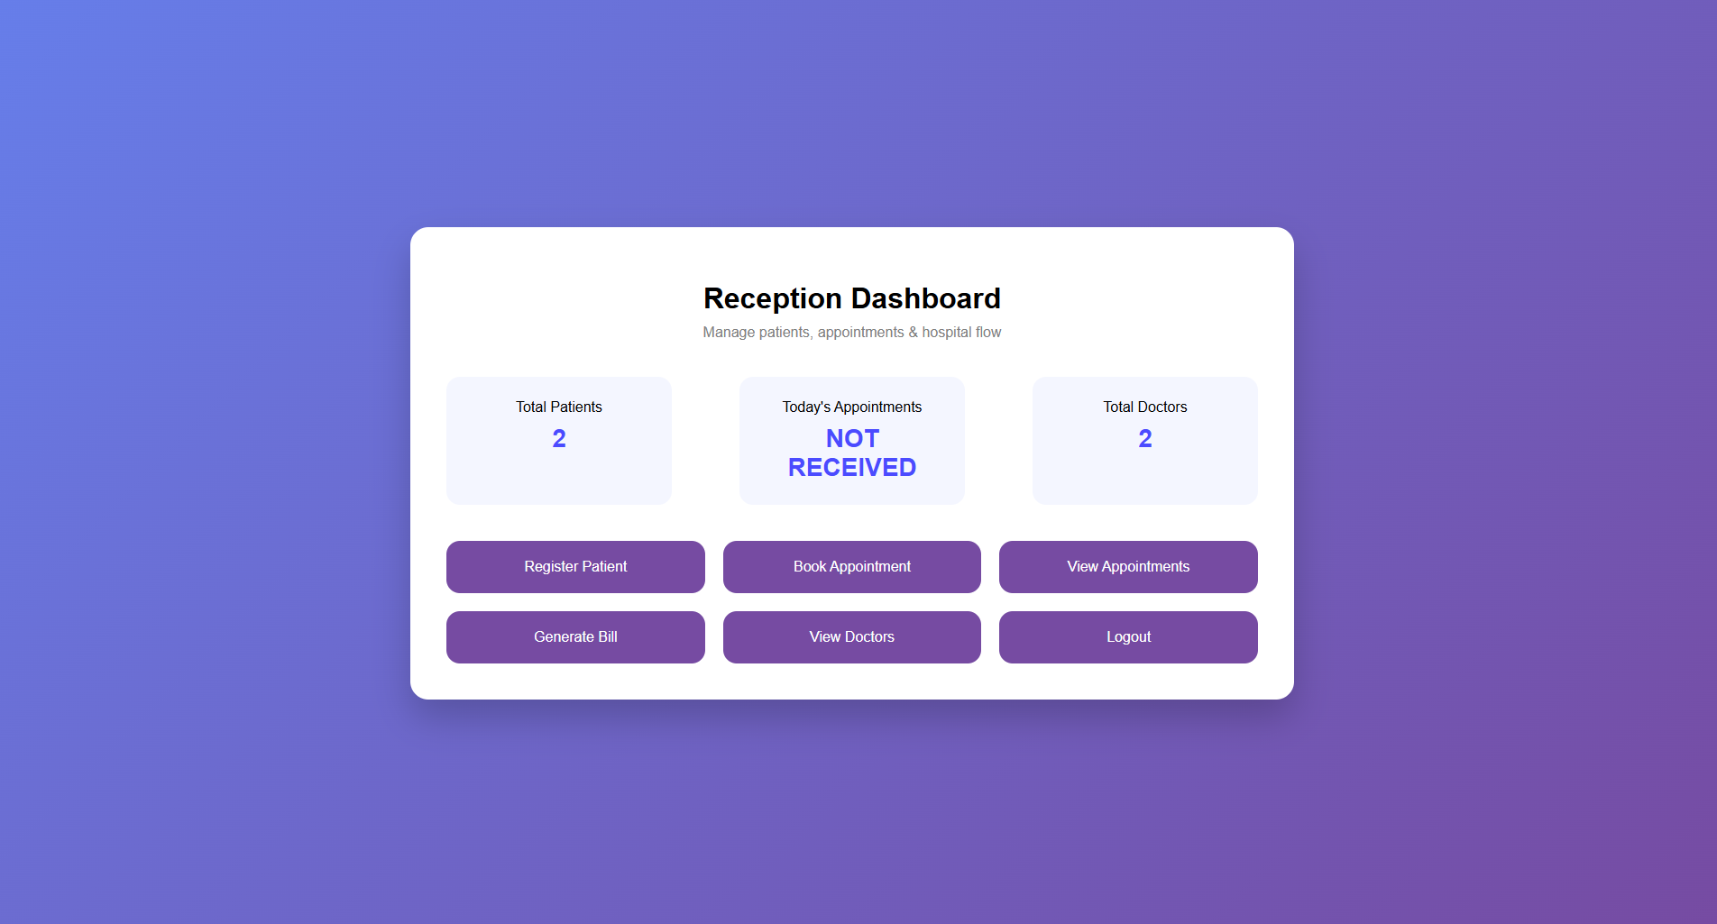

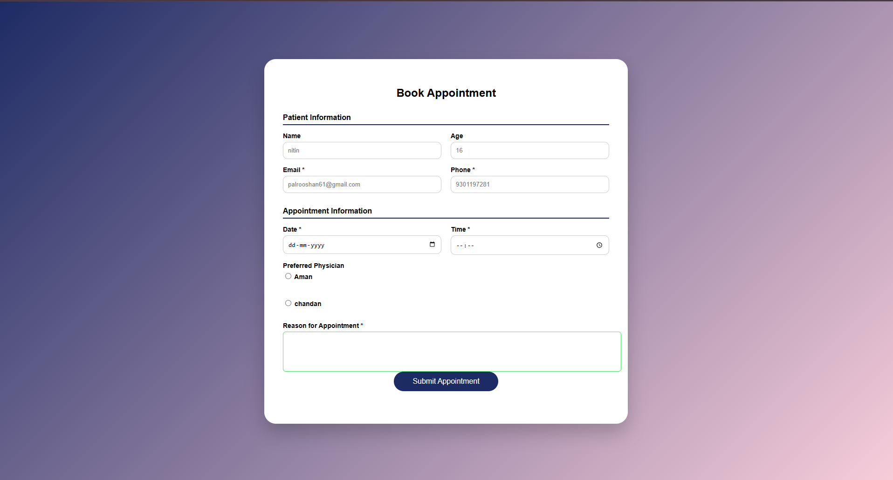

**5-Pharmacist (login page & home page)**

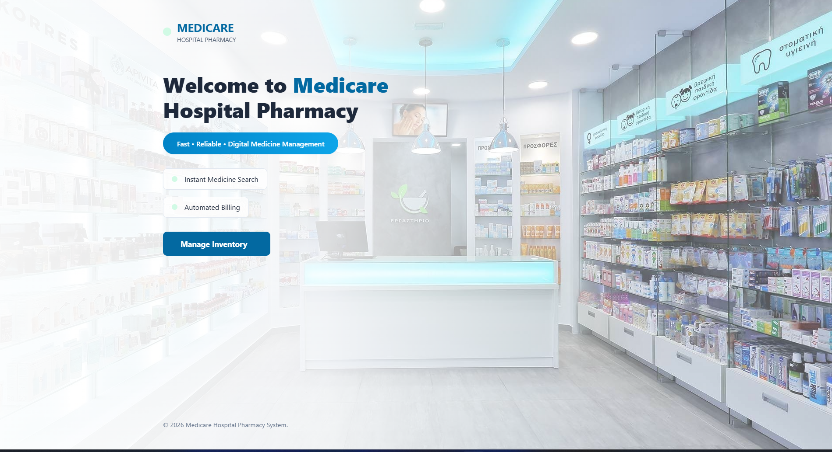

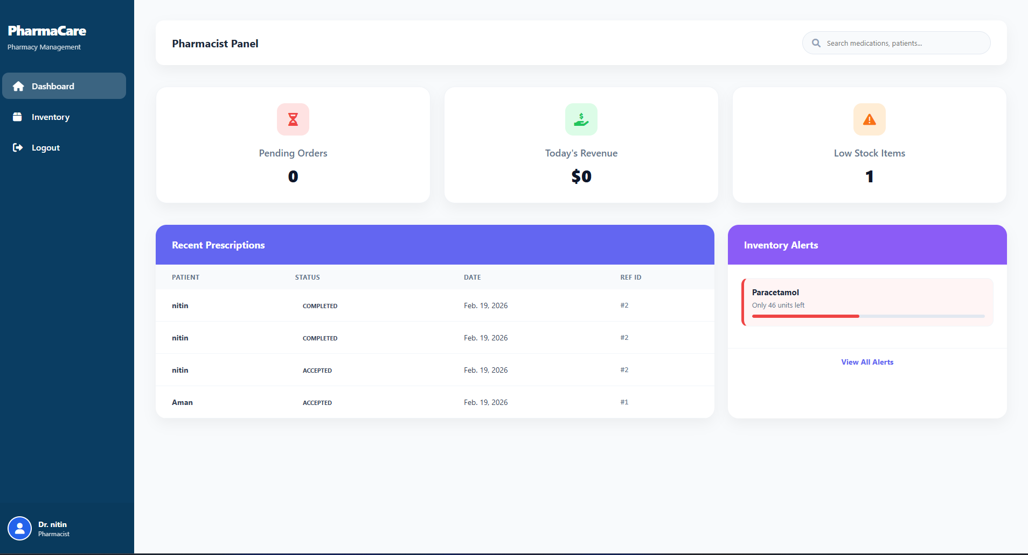

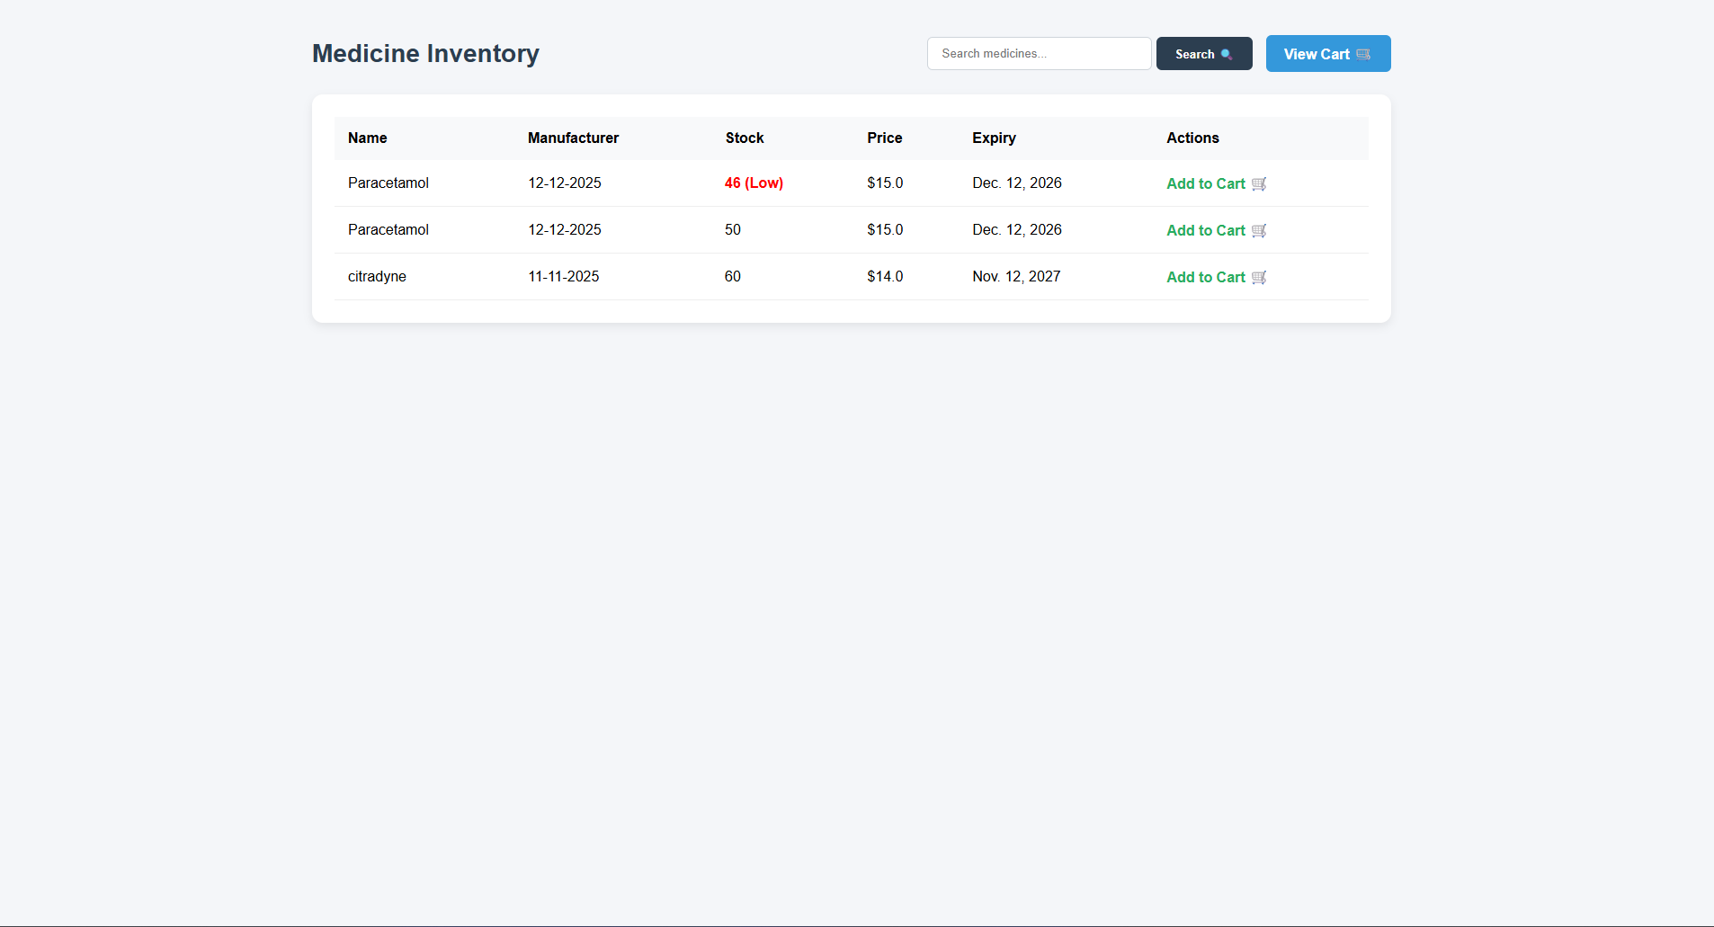

**6-Admin page**

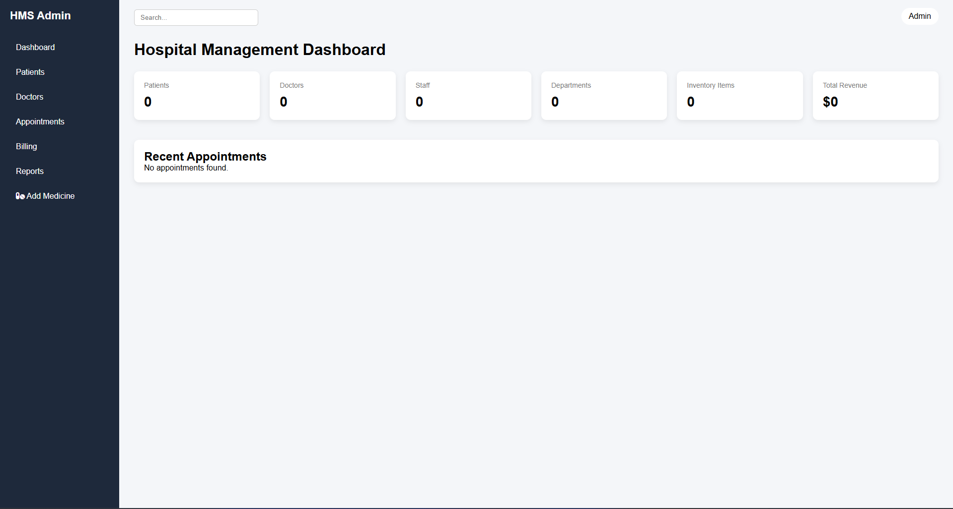

**7. Conclusion**

**The architectural design of the Hospital Management System (HMS) represents a structured and scalable implementation of a modular, database-driven healthcare management platform built using the Django framework. The system successfully integrates authentication management, prescription upload handling, pharmacy inventory control, shopping cart workflow, and automated billing processes within a unified multi-tier architecture.**

**The relational database schema enforces Referential Integrity across core entities such as Patients, Pharmacists, Medicines, Prescriptions, and Orders, ensuring consistent and reliable transactional workflows. The use of Django ORM provides optimized database interaction while preventing common security vulnerabilities such as SQL injection. Session-based authentication combined with CSRF middleware ensures secure user access and controlled dashboard routing.**

**The system demonstrates a balanced integration of backend logic and frontend dashboard interfaces, ensuring both operational efficiency and user-friendly interaction. By leveraging Django’s structured application separation, the architecture remains modular, maintainable, and extendable for future enhancements.**

**Overall, the project achieves its objective of digitizing hospital and pharmacy operations, reducing manual workload, improving inventory tracking accuracy, and enhancing patient service efficiency through secure and structured automation.**